**Task Creator:**

**Data Section:**

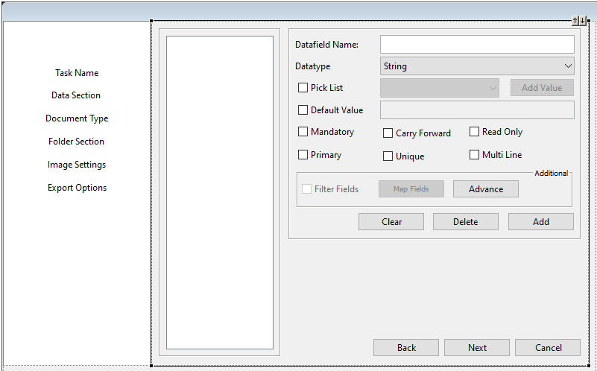

**Variable used:**

1. Datafields Name**: -** txtDataFieldName
2. DataType : - dataTypeCombo
3. Pick List :-
   * Checkbox : chkPickList
   * ComboBox : dataTypeCombo
   * Button : btnAddValueToPickList
4. Default Value :-
   * CheckBox : chkDefaultValue
   * Text-Fields : txtDefaultValue
5. Mandatory : chkMandory
6. Carry Forward : chkCarryForward
7. Read Only : chkReadOnly
8. Primary : chkPrimary
9. Unique : chkUnique
10. Multi Line : chkMultiLine
11. FilterFields :